**6 One vs all logistic regression (15 points)**

**Download the data**

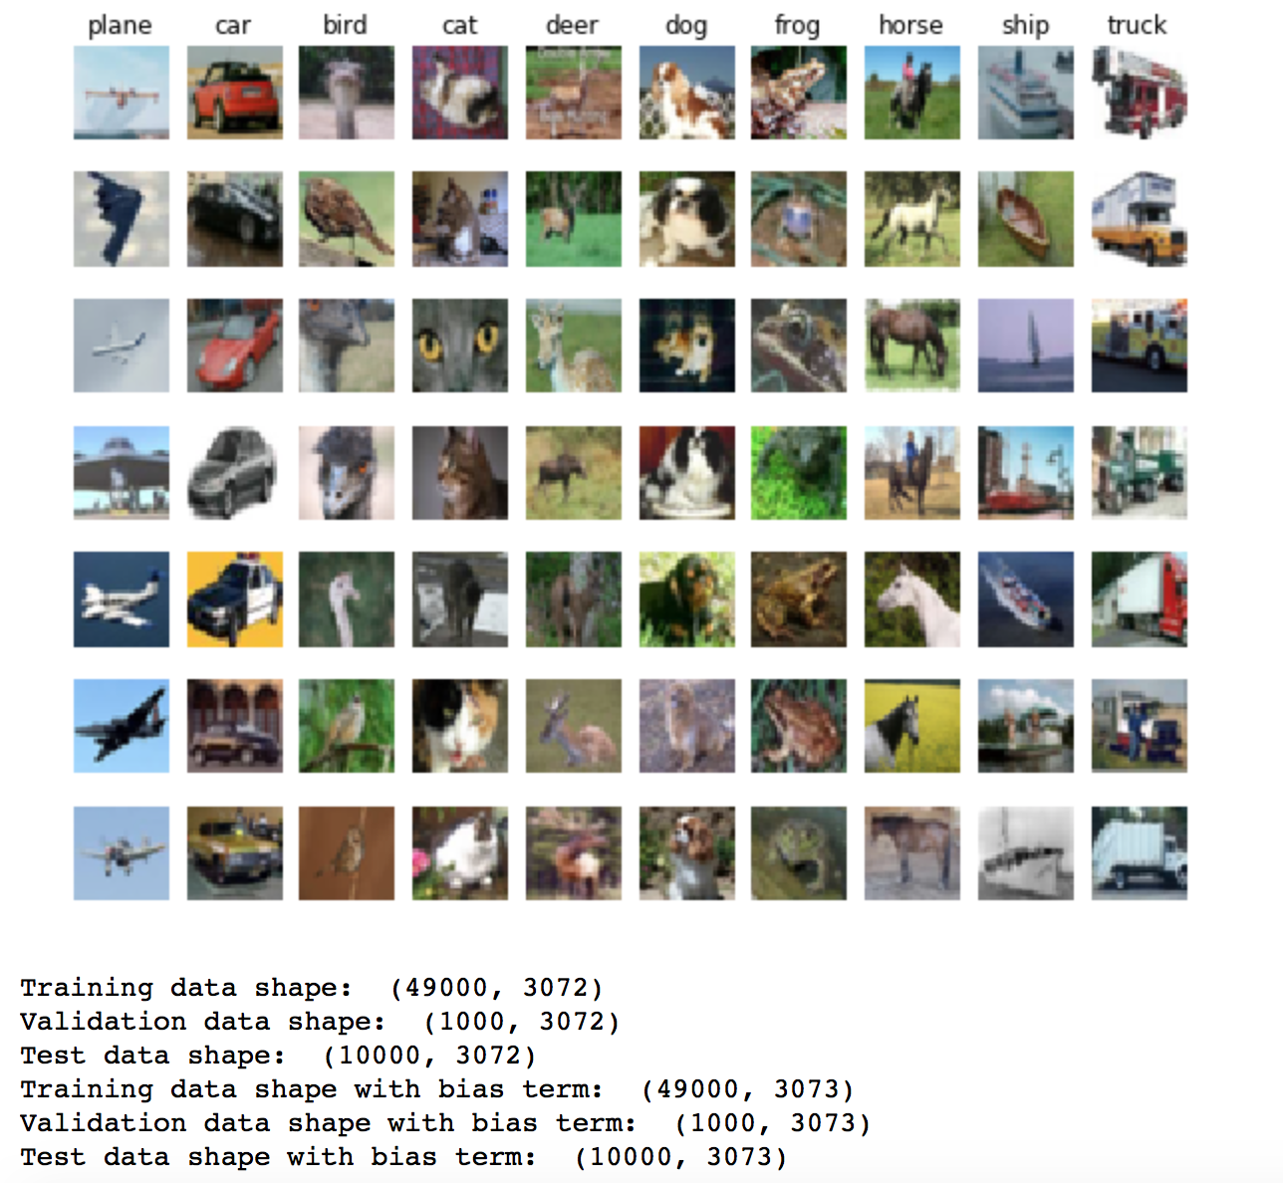

**Problem 6.1. Implementing a one-vs-all classifier for the CIFAR-10 dataset**

**Problem 6.2: Predicting with a one-vs-all classifier (5 points)**

**Implementing a one_vs_all classifier for CIFAR-10**

*one_vs_all on raw pixels final test set accuracy: 0.362000*

*[[465 59 21 24 19 35 26 60 201 90]*

*[ 67 465 18 35 23 31 44 50 94 173]*

*[123 65 193 77 96 89 151 89 69 48]*

*[ 66 86 78 161 49 193 171 51 62 83]*

*[ 65 38 103 64 234 90 194 128 36 48]*

*[ 48 63 81 126 81 272 114 88 72 55]*

*[ 31 53 67 102 85 78 457 52 29 46]*

*[ 53 62 51 46 69 84 66 405 49 115]*

*[143 78 8 25 9 34 22 20 547 114]*

*[ 59 208 14 22 23 29 60 56 108 421]]*

## Visualizing the learned one-vs-all classifier

## /Users/HAI/Desktop/SPRING 2018/COMP540/hw3/ova1.pdf

**Comparing your OVA classifier with sklearn’s classifier**

## Comparing your functions with sklearn's

*one_vs_all on raw pixels final test set accuracy (sklearn): 0.362000*

*[[465 59 21 24 19 35 26 60 201 90]*

*[ 67 465 18 35 23 31 44 50 94 173]*

*[123 65 193 77 96 89 151 89 69 48]*

*[ 66 86 78 161 49 193 171 51 62 83]*

*[ 65 38 103 64 234 90 194 128 36 48]*

*[ 48 63 81 126 81 272 114 88 72 55]*

*[ 31 53 67 102 85 78 457 52 29 46]*

*[ 53 62 51 46 69 84 66 405 49 115]*

*[143 78 8 25 9 34 22 20 547 114]*

*[ 59 208 14 22 23 29 60 56 108 421]]*

## Visualizing the sklearn OVA classifier

/Users/HAI/Desktop/SPRING 2018/COMP540/hw3/ova2.pdf

**Comment on the difference between my ova classifier with sklearn’s classifier:**

Running my OVA classifier and sklearn’s classifier, we get exactly the same test set accuracy: 0.36200. The confusion matrixes of these two classifiers are also same. But when visualizing plot by these two classifiers, the contour of animals’ images of my OVA classifier is clearer than images of sklearn’s classifier.

**7 Softmax regression (45 points)**

**Problem 7.1: Implementing the loss function for softmax regression (naive version) (5 points)**

## Implementing softmax regression for the CIFAR-10 dataset

## Load the CIFAR-10 dataset

## Implementing the loss function for softmax regression (naive version)

*loss: (should be close to 2.38): 2.26697618699*

We should expect to see a value of about **−loge(0.1)** since the numerator is the exponential of theta in kth category, and the denominator is sum of all K categories, so the ratio will approximately be the one divided by 10, which equal to 0.1.

**Problem 7.2: Implementing the gradient of loss function for softmax regression (naive version) (5 points)**

## Implementing the gradient of loss function for softmax regression (naive version)

*numerical: 1.219896 analytic: 1.219896, relative error: 9.607892e-09*

*numerical: 0.412196 analytic: 0.412196, relative error: 7.575155e-08*

*numerical: 0.121181 analytic: 0.121181, relative error: 1.035536e-07*

*numerical: -0.544416 analytic: -0.544416, relative error: 1.309612e-07*

*numerical: 0.526976 analytic: 0.526976, relative error: 1.123345e-07*

*numerical: -0.417867 analytic: -0.417867, relative error: 8.238003e-08*

*numerical: 0.912383 analytic: 0.912383, relative error: 3.395058e-08*

*numerical: 1.382606 analytic: 1.382606, relative error: 3.140028e-09*

*numerical: -2.399155 analytic: -2.399155, relative error: 3.383841e-08*

*numerical: 1.027961 analytic: 1.027961, relative error: 1.496*442e-08

*naive loss: 2.266976e+00 computed in 16.693439s*

**Problem 7.3: Implementing the loss function for softmax regression (vectorized version) (10 points)**

**Problem 7.4: Implementing the gradient of loss for softmax regression (vectorized version) (5 points)**

## Implementing the loss function and its gradient for softmax regression (vectorized version)

*vectorized loss: 2.266976e+00 computed in 0.430081s*

*Loss difference: 0.000000*

*Gradient difference: 0.000000*

**Problem 7.5: Implementing mini-batch gradient descent (5 points)**

## Implementing mini-batch gradient descent

**Problem 7.6: Using a validation set to select regularization lambda and learning rate for gradient descent (5 points)**

## Using a validation set to select regularization lambda and learning rate for gradient descent

*best validation accuracy achieved during cross-validation: 0.418000*

**Problem 7.7: Training a softmax classifier with the best hyperparameters (5 points)**

## Evaluating the best softmax classifier on the test set and visualizing the coefficients/Users/HAI/Desktop/SPRING 2018/COMP540/hw3/7.7.png

*softmax on raw pixels final test set accuracy: 0.396200*

*[[466 53 47 26 11 27 31 49 199 91]*

*[ 58 484 31 30 17 37 54 35 79 175]*

*[ 98 61 245 79 94 79 182 72 63 27]*

*[ 36 68 89 219 44 182 172 51 62 77]*

*[ 56 33 147 44 251 87 211 105 32 34]*

*[ 46 57 95 133 64 334 107 64 68 32]*

*[ 10 45 64 96 81 78 520 41 23 42]*

*[ 55 50 63 46 79 73 65 420 49 100]*

*[168 75 15 20 5 41 19 19 518 120]*

*[ 64 180 16 19 11 26 45 47 87 505]]*

**Comment:**

Focusing on error made by classifier, we find the confusion categories will happen correspondingly. In another word, one category ‘A’ is easily recognized as another ‘B’ means ‘B’ will also easily be recognized as ‘A’. As we can see in confusion matrix, we can see small animals are easy to be misrecognized, for example, bird, cat, deer, dog and frog are easy to be recognized as others. Other sets of categories easy to be mixed, like car and truck, plane and ship, truck and ship, horse and truck, might because they are similar in shape or size.

**Extra credit: Problem 7.8: Experimenting with other hyper parameters and optimization method (10 points)**

## Extra credit: Experimenting with other hyper parameters and optimization method

**Produce plots that show the variation of test set accuracy as a function of batch size/number of iterations.**

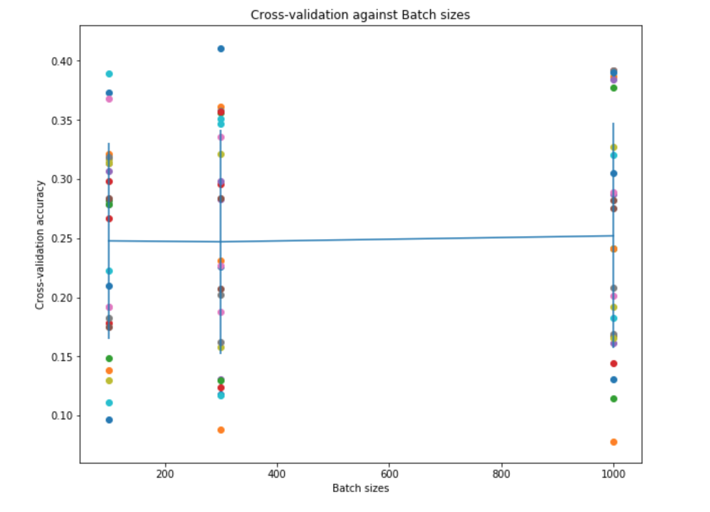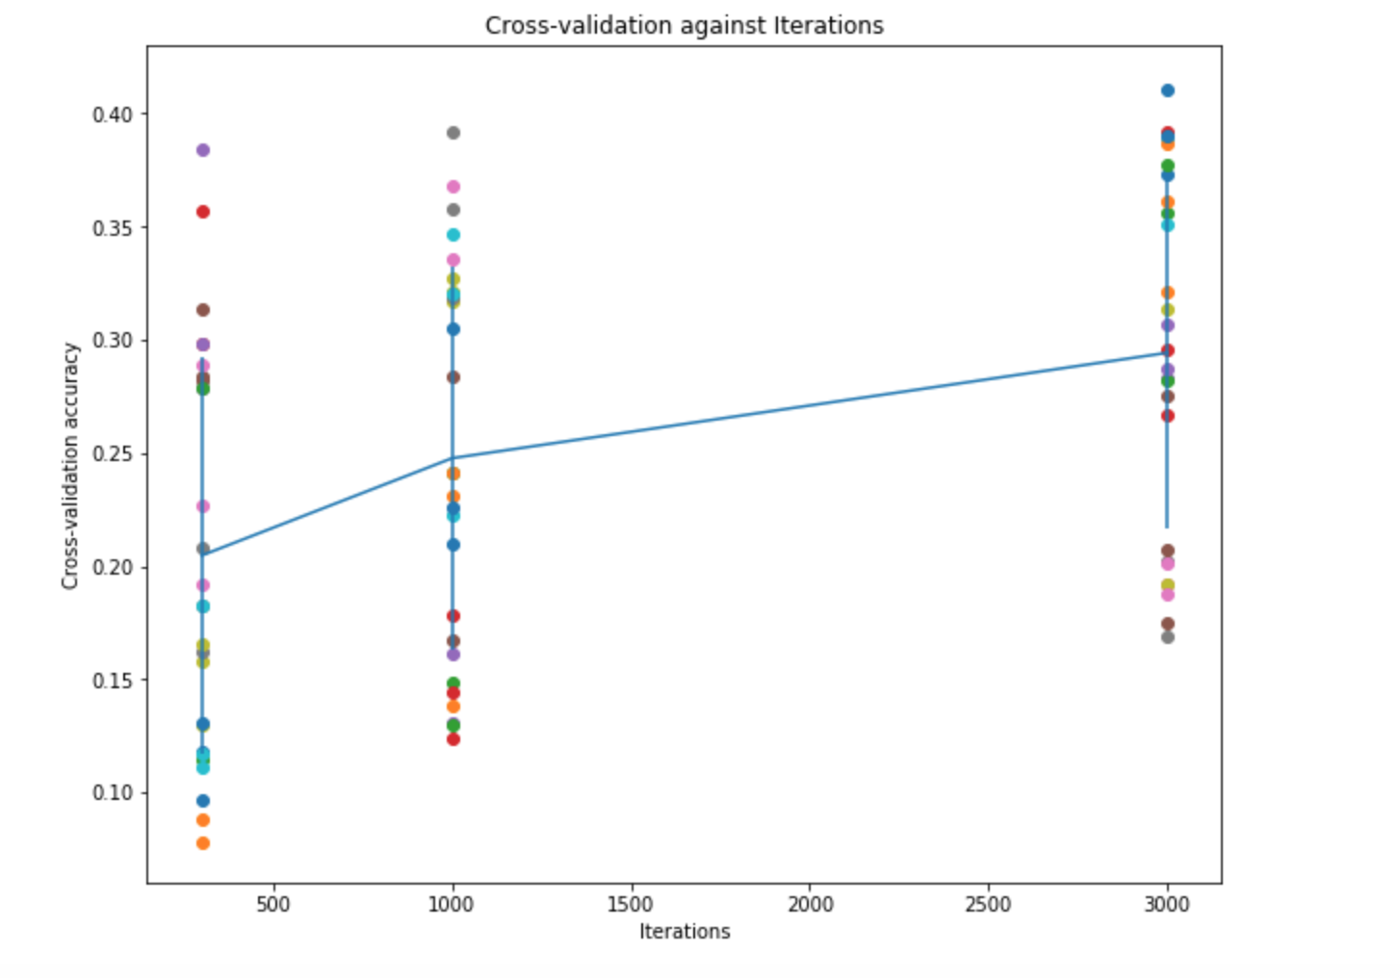

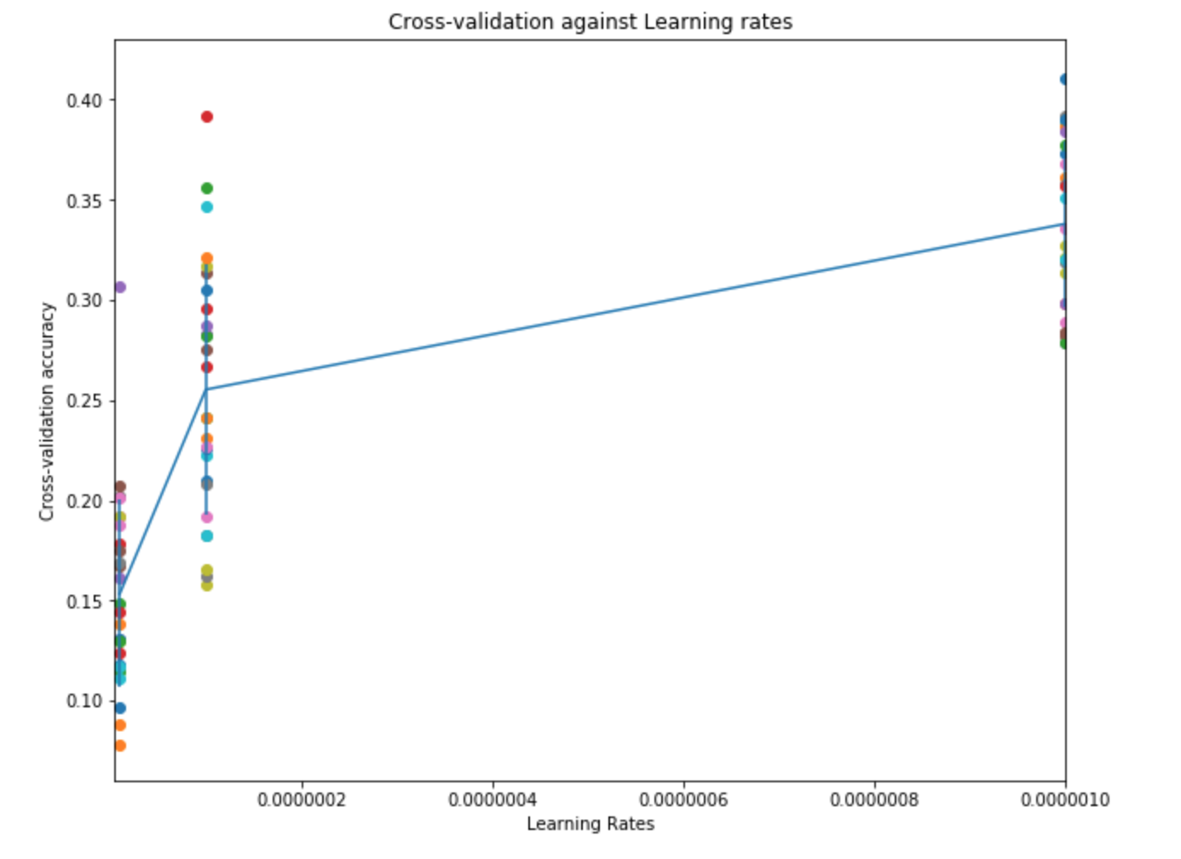

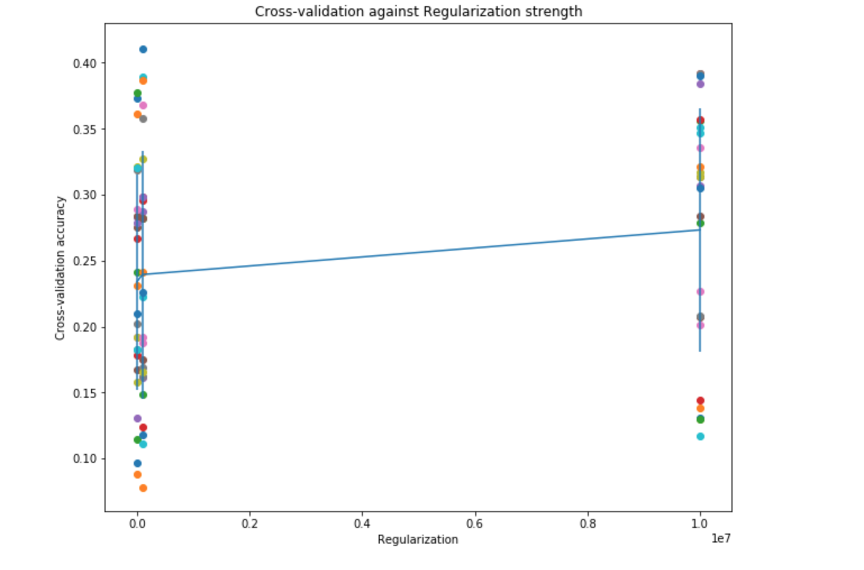

*Softmax on raw pixels final test set accuracy: 0.396200.*

*iter 3000 size 300 lr 5.000000e-06 reg 1.000000e+05 train accuracy: 0.412878 val accuracy: 0.419000*

*iter 3000 size 300 lr 5.000000e-06 reg 1.000000e+06 train accuracy: 0.398776 val accuracy: 0.400000*

*iter 3000 size 300 lr 5.000000e-06 reg 1.000000e+07 train accuracy: 0.336469 val accuracy: 0.346000*

*iter 3000 size 300 lr 5.000000e-06 reg 1.000000e+05 train accuracy: 0.424735 val accuracy: 0.414000*

*iter 3000 size 300 lr 5.000000e-06 reg 1.000000e+06 train accuracy: 0.375694 val accuracy: 0.372000*

*iter 3000 size 300 lr 5.000000e-06 reg 1.000000e+07 train accuracy: 0.289204 val accuracy: 0.312000*

*iter 3000 size 300 lr 5.000000e-06 reg 1.000000e+05 train accuracy: 0.277918 val accuracy: 0.261000*

*iter 3000 size 300 lr 5.000000e-06 reg 1.000000e+06 train accuracy: 0.225980 val accuracy: 0.225000*

*iter 3000 size 300 lr 5.000000e-06 reg 1.000000e+07 train accuracy: 0.142653 val accuracy: 0.148000*

*Best validation accuracy achieved during cross-validation is 0.419000 by iter 3000 size 300 lr 5.000000e-06 reg 1.000000e+07.*

*Softmax on raw pixels final test set accuracy: 0.393300.*

**What is the best batch size/number of iterations/learning rate/regularization strength combination for this problem? What is the best test set accuracy that can be achieved by this combination?**

**Answer:**

The best batch size for this question is *300*, best number of iterations is *3000*, the best learning rate is *5.000000e-06* and the best regularization strength is *1.000000e+07.*

Moreover, the best test set accuracy that can be achieved by this combination is: *0.393300.*

**Problem 7.9. Comparing OVA binary logistic regression with softmax regression (5 points)**

|  |  |  |  |  |  |  |  |  |  |  |
| --- | --- | --- | --- | --- | --- | --- | --- | --- | --- | --- |
| Correct recognized number of two methods | | | | | | | | | | |
|  | plane | car | bird | cat | deer | dog | frog | horse | ship | truck |
| OVA | 465 | 465 | 193 | 161 | 234 | 272 | 457 | 405 | 547 | 421 |
| Softmax | 466 | 484 | 245 | 219 | 251 | 334 | 520 | 420 | 518 | 505 |

The test accuracy by OVA is 0.362000, while test accuracy by Softmax 0.396200

**Comment:**

Their performance is close but still has 3% difference. The softmax classifier is better. So I will choose softmax classifier method for the CIFAR-10 classification problem.